

LANDIS-II Visualization Tool v1.0

This tool enables forest managers, researchers and other users to quickly and easily view maps and charts from LANDIS-II without using ArcMap or Excel.
For best results, use a current Mozilla Firefox or Google Chrome browser. The Visualization tool will work with Internet Explorer but it works best with Firefox or Chrome.

Getting Started
Use the website provided by the modeler to utilize the visualization tool. Click on the hyperlink to pull up the main menu. Initially there will not be any maps or charts displayed on your screen; only the main drop down menu will be shown on your computer.
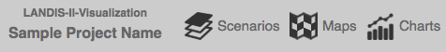
To display a map or chart, click on the word “Scenarios” and then use the corresponding drop down menu to select which scenario you want to visualize. You can select one scenario (e.g. climate change scenario) or compare more than one scenario by selecting multiple scenarios (up to 4) in the scenario drop down menu (click in boxes to the left of the names).
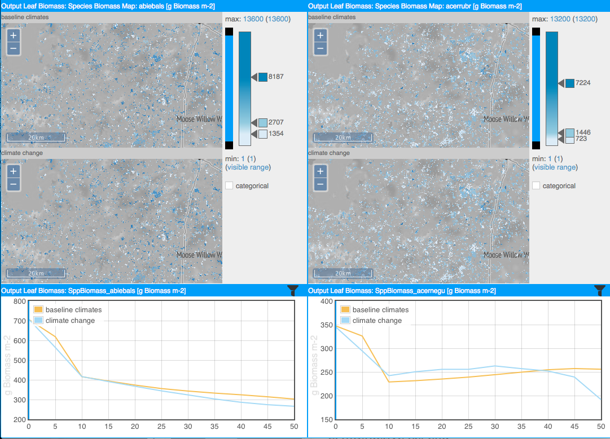
Each scenario (e.g. climate change scenario) contains a number of datasets that can be visualized as maps or charts. Datasets are organized by the LANDIS-II extensions that produced them in the drop down menus. To display maps, click on the word “Maps” to see what data are available. Use the check boxes to select the ones you want, and then click on the main screen (white space) to display the maps. To display charts, click on the word “Charts” and select the parameters of interest. Again, click on the main screen to load the charts. You might have to resize your browser window to get them to display in a 2 X 2 arrangement.
The maximum number of displayable maps (or charts) is four.

Changing the Display

The default settings for the charts and maps are calculated based on the dataset statistics over the entire simulation period and scenarios, but you can manually adjust the settings of the maps and charts.
Use the scroll wheel on your mouse or the plus and minus buttons to zoom in and out of the map. Click and drag to pan the map (i.e., move it up, down or sideways). If you navigate in one map window, all other map windows will update to the new location and zoom level automatically.
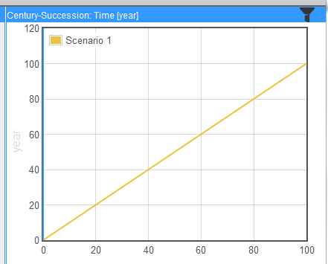
You can adjust the legend/classification bar (see left). To move a break, drag the arrow next to the class break. To add a class, double click on the classification bar or to remove a class, double click on the arrow. Right click the color square next to a class break arrow to assign a different data color to the class. Select the categorical option to switch to color bins, rather than a gradient of colors. To filter map data to show only a certain data range, drag the black squares on the filter bar to adjust the visible range.
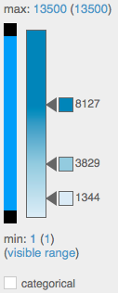
To filter chart data, click the filter icon on the right of the chart’s title bar. Select a filter criterion (e.g. ecoregion) and the chart will only display that particular data.

If you want the legend/classification bar to synchronize across all the displayed maps, then click on the synchronize button in the upper right hand corner.

Viewing Changes over Time
Click the play button on the top menu bar to start a temporal animation.

By default the playback interval is one year. If a parameter on a map has a time interval of 5 years, the map changes every 5th year. Maps where time steps are available only every 10 years, change only every 10th year. On the charts, the moving blue vertical line helps identify parameter values that correspond to the current point in time.
Click on the gears symbol to the right of the temporal animation bar to change the animation speed.

For more detailed information about the tool, please read the LANDIS-II Visualization Tool v1.0 User’s guide or contact Melissa Lucash (lucash@pdx.edu).

Last Revised by M. Lucash: November 7, 2026

